OUR LADY STAR OF THE SEA CATHOLIC PRIMARY SCHOOL
13 - 29 John Dory Drive, Ocean Grove, 3226
Telephone: (03) 5255 4308
www.staroceangrove.catholic.edu.au

2023 Enrolment Information

Application for Enrolment
Application for Enrolment forms are available from the school office or may be downloaded from the school website www.staroceangrove.catholic.edu.au
Applications for enrolment are to be completed and received by the school before Friday 10 June, 2022.

Open Time and School Tours
The school will be open for student led tours on Tuesday 29 March between 9.15am and 10.45am. Parents and children welcome. No bookings are required. All visitors must be double Covid-19 vaccinated and show proof on arrival at the school.

Information Session for Parents
Parents are invited to an information session on Tuesday 29 March at 6.30pm – 7.30pm. All visitors must be double Covid-19 vaccinated and show proof on arrival at the school.
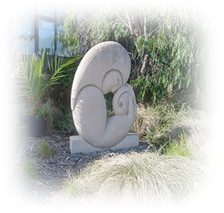
Interviews with the principal
Appointments for an interview with the principal will be offered after applications have been
received.
For further information regarding enrolment please contact the school office or email secretary@staroceangrove.catholic.edu.au

